# SQLDeleteStep

**Objective:**

It is used to execute the DELETE SQL in selected DB.

**Attributes:**

|  |  |
| --- | --- |
| **Attributes** | **Description** |
| value | Enter query to execute |
| value_type | To select type as free marker template or handlebar |
| plugin_name | To connect with mysql server based on the plugin credentials |
| output_variable | Used to store the response of the request |

**Sample config.json:**

{

"workflows": [

{

"name": "delete_books",

"id": 200,

"trigger": "rest",

"expression": "bookapp/{id}",

"method": "GET",

"steps": [

{

"type": "start",

"id": 1,

"next": {

"start": "start"

}

},

{

"value": "DELETE FROM testDB.employee_table WHERE id = ${request.path.id};",

"value_type": "ftl",

"output_variable": "sql-delete",

"plugin_name": "book_db",

"type": "sql-delete",

"id": "start",

"next": {

"success": "delete-success",

"failure": "hangup"

}

},

{

"variable_name": "sql-delete",

"http_response_code": "200",

"response_content_type": "text/html",

"value_type": "hb",

"type": "send",

"id": "delete-success",

"next": {

"success": "hangup",

"failure": "hangup"

}

}

]

}

],

"filters": [],

"server": {},

"plugins": [

{

"id": 243,

"name": "book_db",

"type": "mysql-plugin",

"version": "1.0",

"category": "Database",

"server": "localhost",

"username": "root",

"password": "root",

"schema": "testDB"

}

]

}

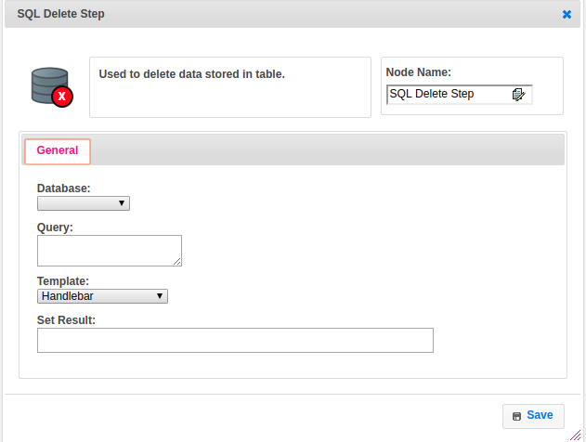

**Executor Description:**

* In executor class first will get connection to database based on the plugin handler credentials to respective schema.
* By using the SQLDBUtil class we will delete the data based on the query or value which given by user and put result into output variable then returns success.